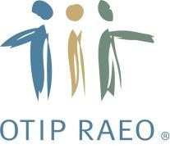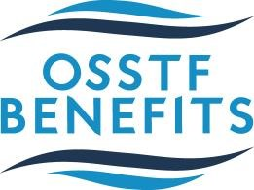

ENHANCEMENT #1 – ADDITION OF PSYCHOTHERAPY

Dear OSSTF Member,
We are pleased to announce that as of October 1, 2017 your OSSTF ELHT Provincial benefits plan now includes psychotherapy.
What is Psychotherapy?
Psychotherapy is a term that covers all talking therapies and the many associated approaches/methods. Psychotherapists are mental health professionals who use "talking therapy" or counselling to help people work through difficult issues, rather than medications or physical interventions. People generally see psychotherapists when their problems affect their day-to-day living.

What is the benefits coverage?

Psychotherapy will be added to your plan at 100% coverage up to $2,000 per Plan Year combined for services of a psychologist, marriage and family therapist, social worker and psychotherapist. All psychotherapists must be licensed and registered in the province of coverage and all claims are subject to reasonable and customary charges.

Additional questions?
For more detailed information on this new benefit, please review your benefits booklet located in My Claims.

If you have any questions about your benefits plan, or if a claim would be eligible for coverage, please contact OTIP Benefits Services at 1-866-783-6847.

