  - 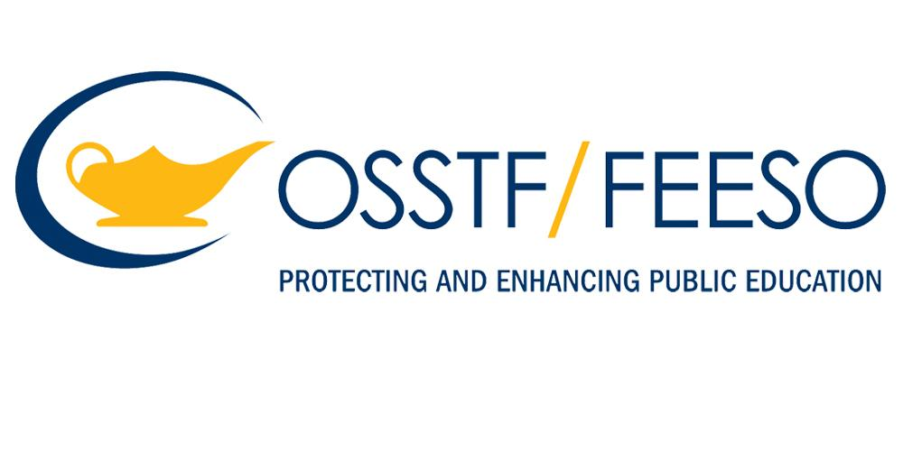
  - sponsored public skate
  - march 15th
This event is open to all members of the community. Please exercise caution and be Respectful of other skaters.
Guelph | Elora | Orangeville
Centennial Arena  j  2:00-3:50 pm | Elora & District Community Centre  1:00-3:30 pm | Alder Street Arena g  1:00-3:30 pm

